Fortes TKX Mid Shift Kit

Tools Required
-needle nose pliers
-regular pliers
-cutters
-hammer
-3/16 punch
-bigger punches
-10mm socket
-T30 bit
-rags
-red grease
-blue Loctite
-torque wrench

When building a Mark IV Factory Five Roadster the stock position of the shifter in the TKX will get in the way of the cross bracing of the transmission tunnel. Moving to the mid position will clear all bracing and have a much more comfortable aggressive shifting position, and allow for a nice short throw.

Step 1: Remove the stock shifter from the rear end of the transmission using the 10mm socket. The kit comes with new bolts for the new Fortes branded cover plate.

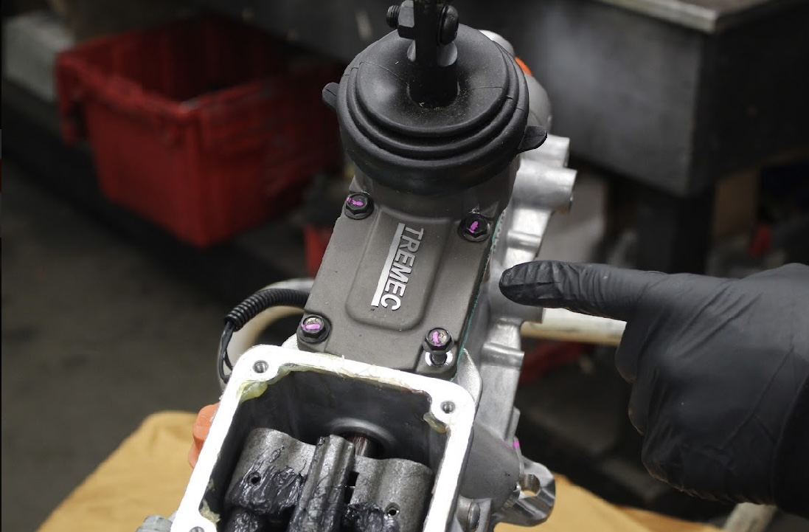
Step 2: Remove the square cover plate using the T30 bit. This is the location of the new shifter. The kit comes with new bolts for the new shifter.

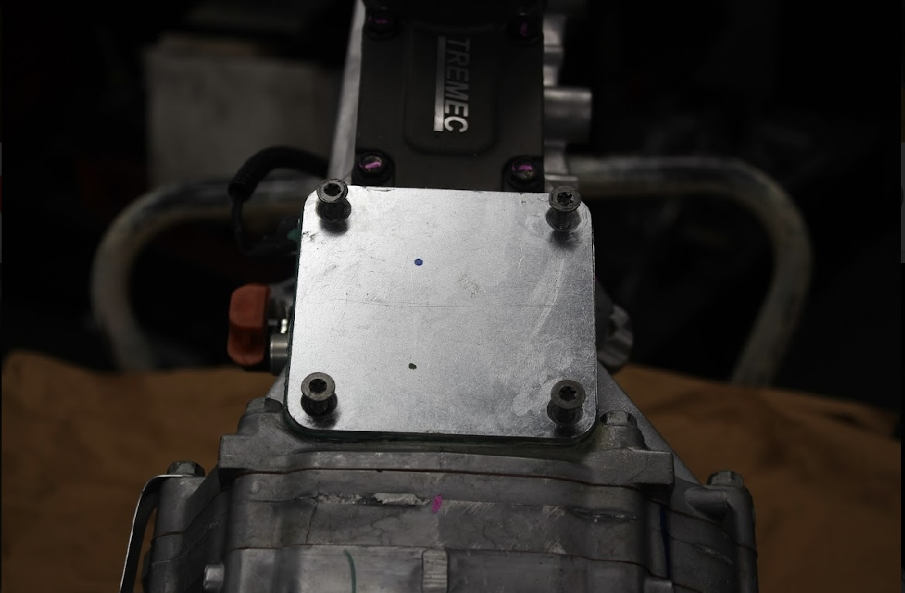

Step 3: As a precaution, slide a rag under the center shifter selector. Take your 3/16 punch and lightly tap the pin. You’ll have to feel this out. It takes patience and care not drive the pin too far. You want to hit the pin little by little until the center selector moves freely. That way you know you’ve driven the pin through the shaft, but not out of the other end of the selector. Go slow and little by little. I can’t stress this enough.

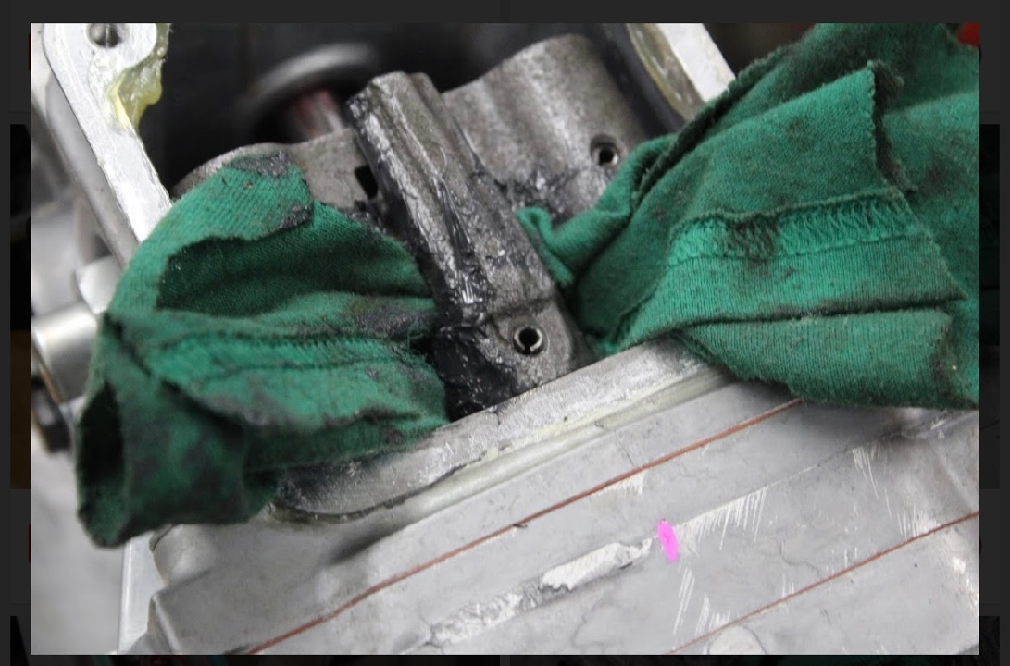
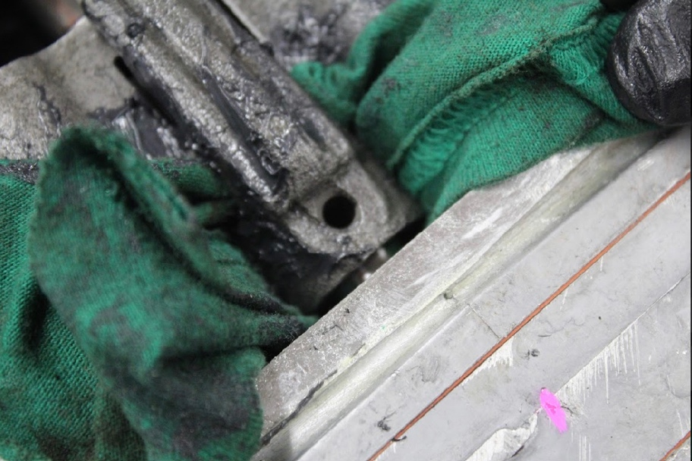

You will need another punch to drive the shaft back in order to wiggle out the center selector.

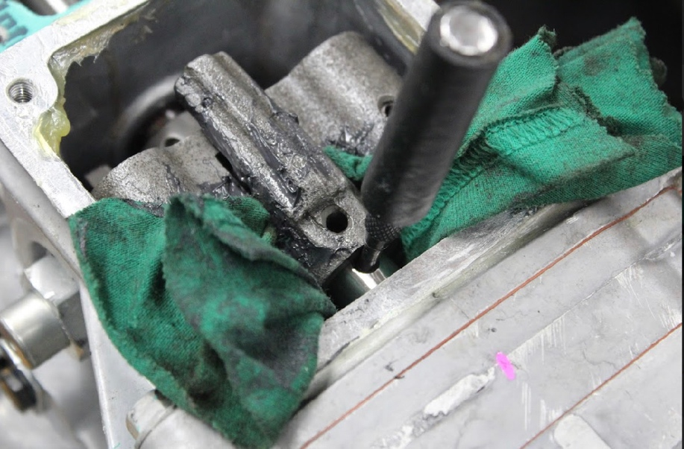

Once you remove the selector you will need to completely remove the pin to be used with the new center selector that came with the kit.

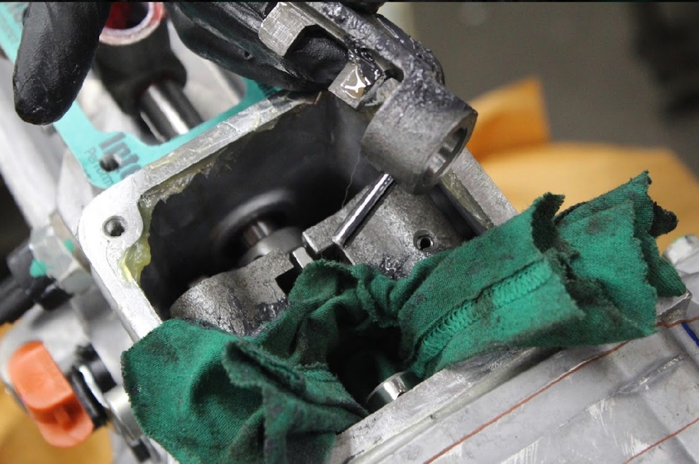

Step 4: Using the same technique as before, you can lightly tap the pin on the lowest selector. Again, make sure you don’t knock it all the way out.

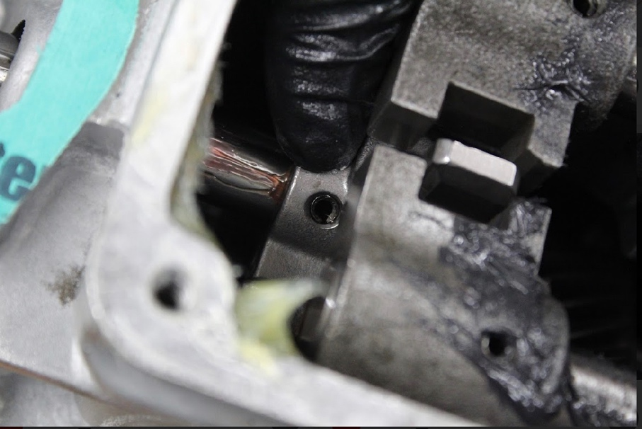

Step 5: We won’t need the lower selector for the new shifter. In order to remove it, we will need to get the upper left and right selectors out of the way. Tap the pins on the left and right using the same technique as before until they are both able to rotate up and down on the shafts. When you can access the pin from below, use your cutters to grab the pin and pull it out.

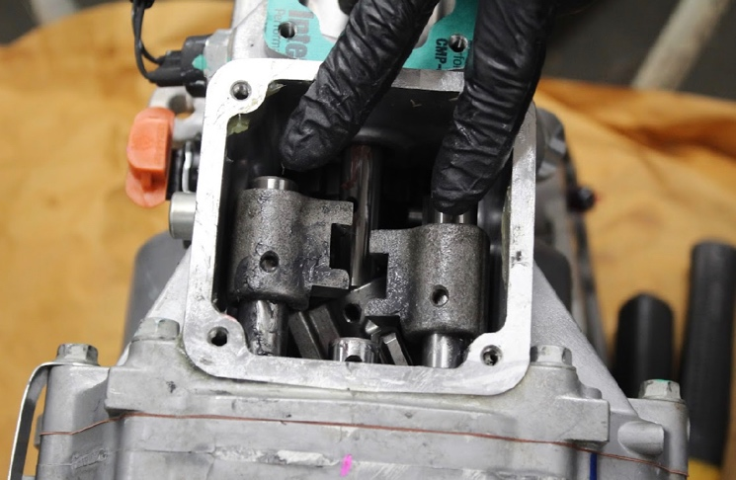

You will have to use a punch or two to hold back the shafts so that you can slide and rotate the left/right selectors to access and remove the pins

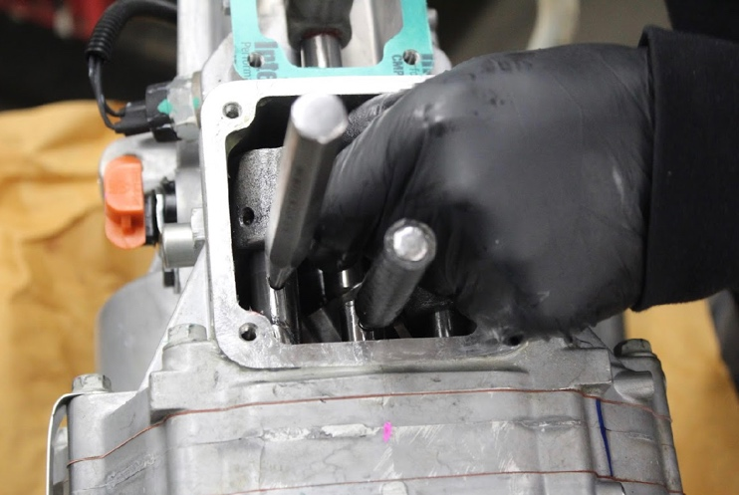

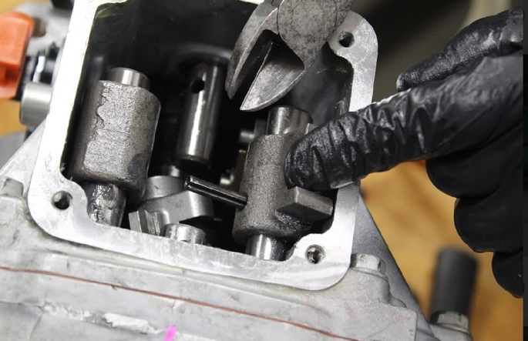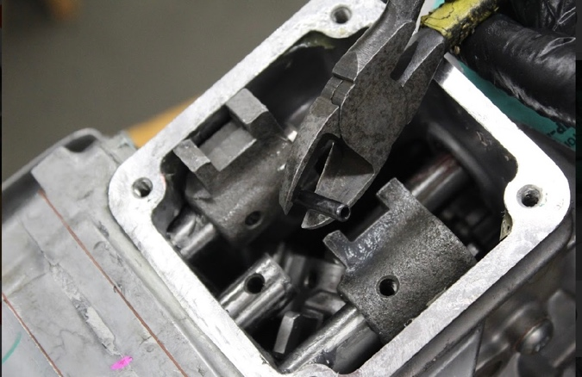
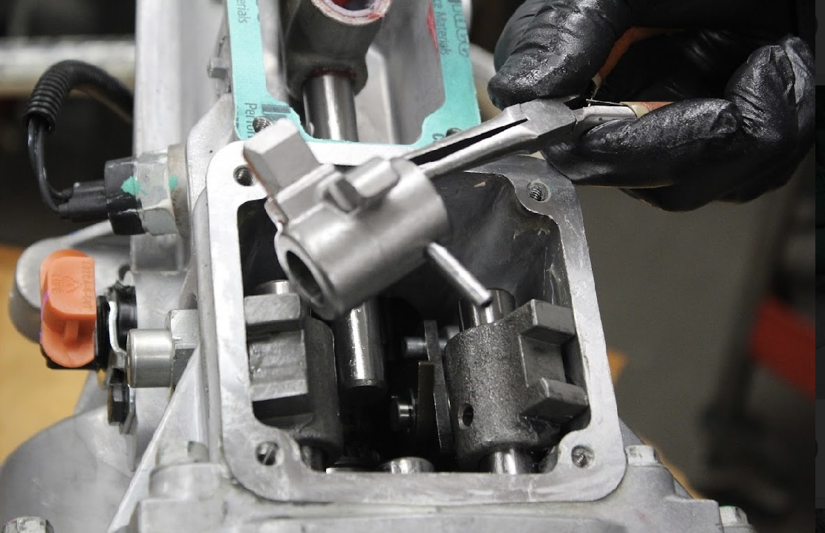

Remove this lowering section takes some fiddling around. The left and right need to be moved upright as shown in the pictures for you to find the right spot that you can remove it. Take your time.

Step 6: Now it’s time to re-assemble the selectors. Take note, that the middle selector provided in the kit, is now re-mounted on the center shaft upside down making room for the new shifter. Insert the pins you removed, and hammer them back in flush.

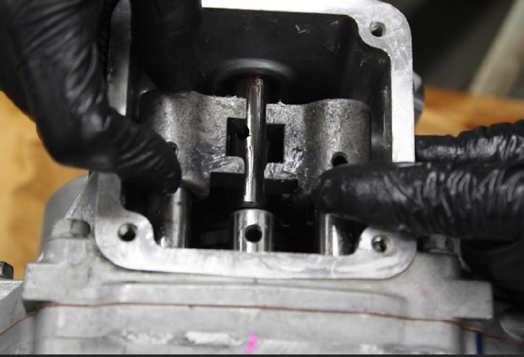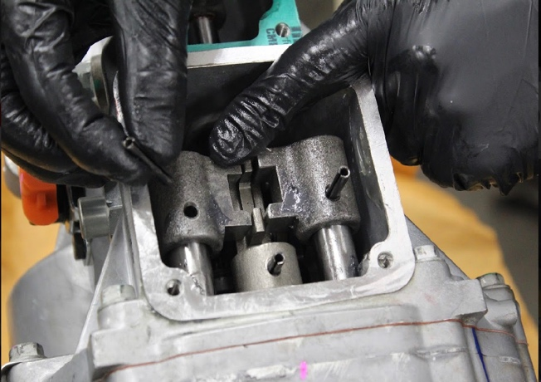
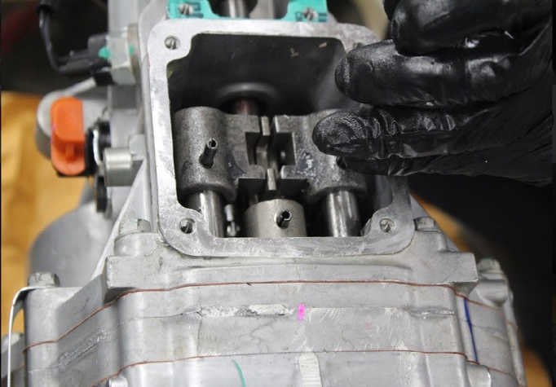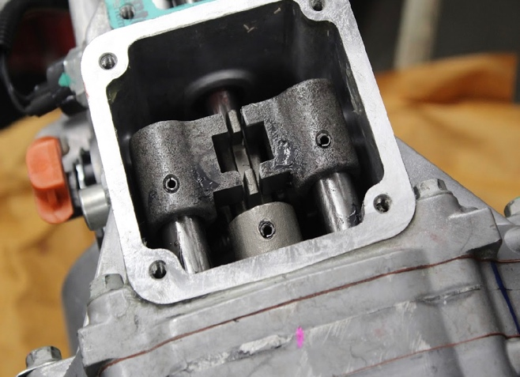

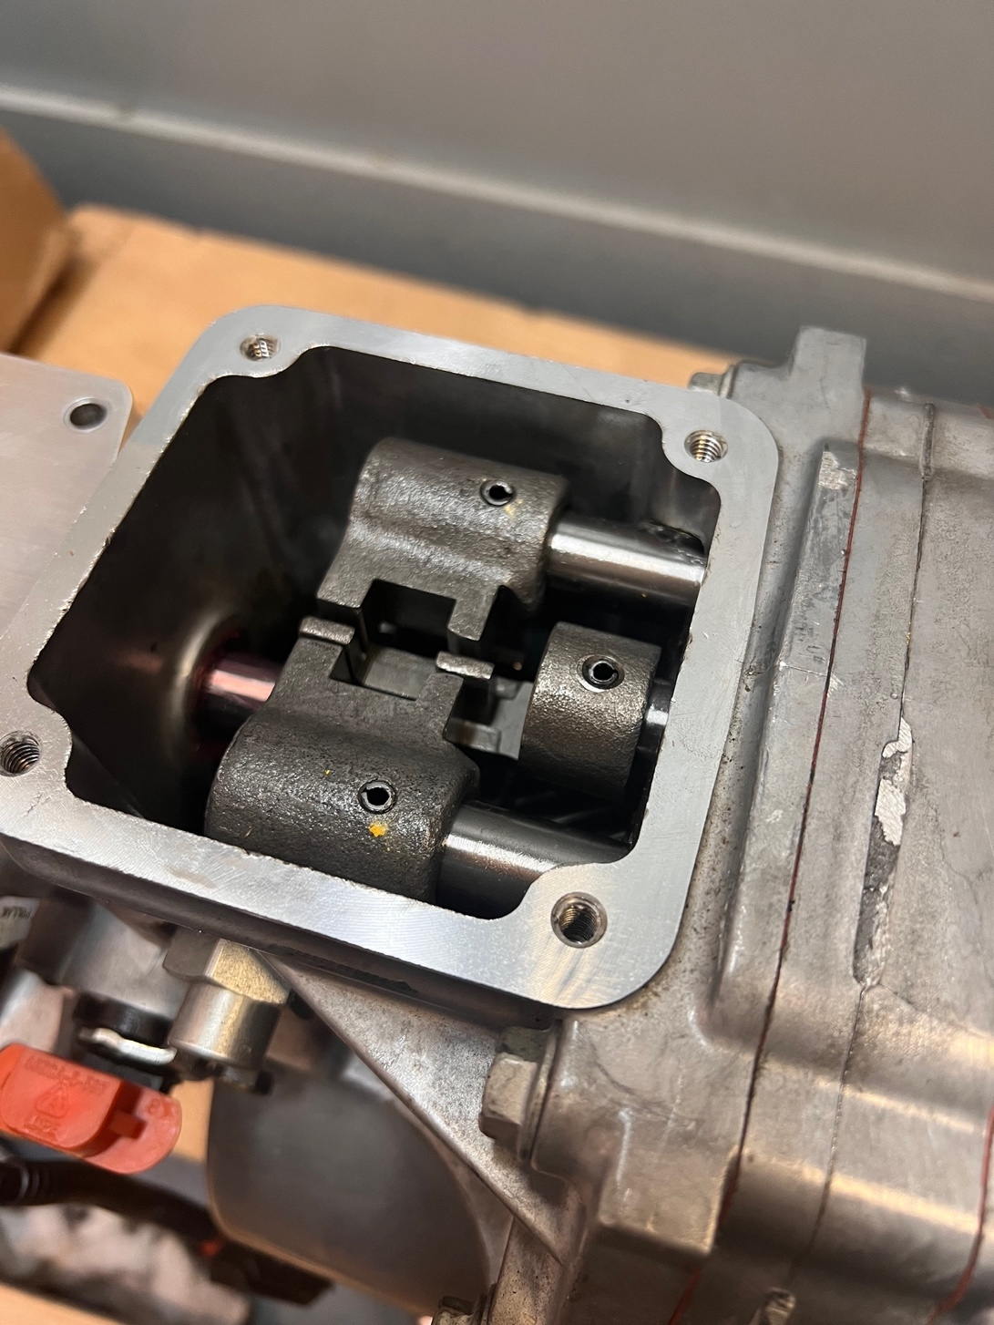

Step 7: Apply some red grease in the square area that the new shifter will slide into. You can now place the new shifter on top lining up the screw holes. Apply some blue Loctite on the new bolts provided. Using a 10mm socket, torque the bolts to 11 foot/lbs

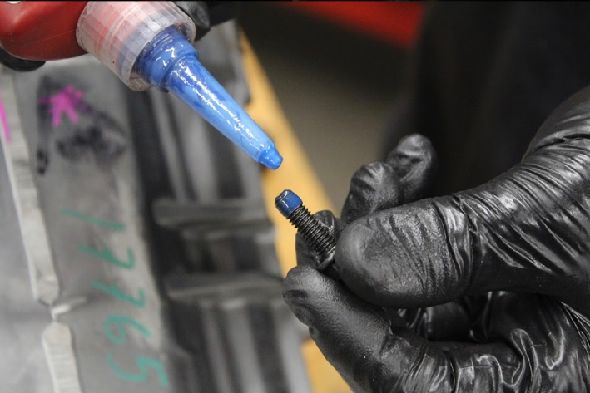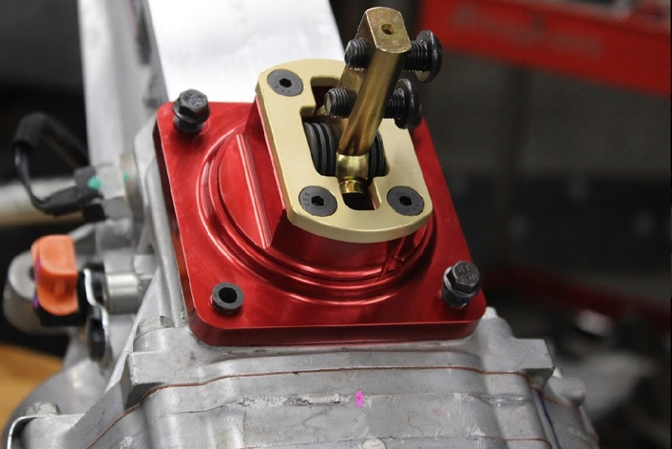

Step 8: Install the Fortes branded cover plate on the old shifter location, apply some blue Loctite on the new bolts provided. Using a 10mm socket, torque the bolts to 11 foot/lbs

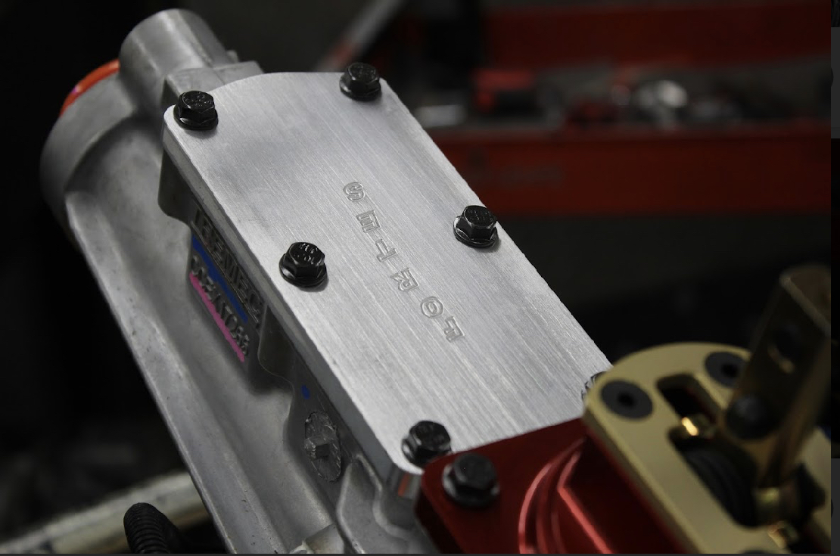

Congrats! You’ve now completely modified your TKX transmission to a mid-shift position. Happy Motoring!

