_______________________
___________________________________________________________________________________

Handbook
for
Replica Vehicle Manufacturers
___________________________________________________________________________________
_______________________

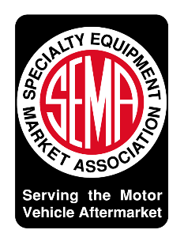

March 9, 2022
Table of Contents

Page
3 Overview
3 General Provisions and Definitions
3 NHTSA Provisions
4 EPA and CARB Provisions
5 Key Definitions & Conditions
5 Size
5 Definition of “Resemble”
- Term “Body”
5 Intellectual Property (IP)
5 Multistage Manufacturing
5 Registration
5 Equipment
- Preemption
6 NHTSA: Registration Process
- First-Time Application to Register
- Updated Registration (New Replica Models)
12 Annual report
- Revocation of Registrations
13 Foreign Company Registration
13 World Manufacturer Identifier (WMI) & Vehicle Identification Number (VIN)
13 VIN Assignments
13 Additional NHTSA Requirements
13 Temporary Label
14 Certification Label
15 Limitations on Exemptions
15 Recordkeeping
15 Imports
15 State Registration and Titling

Disclaimer: the handbook is a supplemental resource for companies seeking to produce replica vehicles and engine packages. Companies should refer to the replica vehicle law and regulations that establish rules and guidance on complying with the replica vehicle program. SEMA assumes no responsibility or liability for any errors or omissions in the content of the handbook.

Replica Vehicle Manufacturer Handbook

The following is a step-by-step guide for companies manufacturing completed replica motor vehicles under the replica vehicle law and associated regulations.

Overview: In 2015, Section 24405 of H.R. 22, the Fixing America’s Surface Transportation Act (FAST Act) established a program whereby the National Highway Traffic Safety Administration (NHTSA) exempts annually up to 325 replica vehicles manufactured or imported by participating low volume manufacturers from Federal motor vehicle safety standards that apply to motor vehicles, but not standards that apply to motor vehicle equipment. The vehicles must contain engine packages certified by the U.S. Environmental Protection Agency (EPA) and, if applicable, issued an Executive Order by the California Air Resources Board (CARB) for current model year emissions standards.

General Provisions and Definitions: Companies producing replica vehicles and engine packages for the vehicles must comply with replica vehicle program requirements. To follow are summaries of the major provisions and definitions.

NHTSA Provisions
- A “low volume manufacturer” is a motor vehicle manufacturer whose annual worldwide production (including by a parent or subsidiary of the manufacturer) is not more than 5,000 motor vehicles each year.
- A low volume manufacturer may construct and sell up to 325 replica vehicles in the U.S. each year.
- A replica vehicle is a vehicle that resembles the body of another motor vehicle produced at least 25 years ago. The vehicle is subject to a license agreement for the intellectual property rights for the replicated vehicle from the original manufacturer, its successor/assignee or the current owner of the replicated vehicle’s intellectual property rights.
- Replica vehicles will be treated as an assemblage of automobile equipment and subject to any current motor vehicle equipment safety standards (lighting, tires, windshields, brake hoses, etc.). The vehicles are exempt from safety standards that apply to motor vehicles (roof crush, side impact, bumper standard, etc.). The exemption recognizes that it is impractical to apply current model year standards to vehicles designed decades ago (ex: 1930’s roadster) or crash-test a vehicle when only a few are being produced.
- Replica vehicles are exempt from the country-of-origin labeling requirement (49 USC 32304), bumper standards (49 USC 32502), average fuel economy standards (49 USC 32902), and from section 3 of the Automobile Information Disclosure Act (15 U.S.C. 1232) (“Monroney sticker”).
- Replica vehicle manufacturers are required to register with NHTSA and file annual production reports. NHTSA has 90 days to approve or deny the registration application (and 30 more days if the application is incomplete). Once approved, a registration may be revoked if the company fails to comply with the program requirements or if NHTSA issues a finding of a safety-related defect which the company has not corrected. Registering with NHTSA is a one-time event, but companies must seek approval of any new replica vehicle models to be sold prior to production.
- A permanent label is to be affixed to the vehicle identifying the standards from which the vehicle is exempt and designating the model year that the vehicle replicates. A temporary label is to be attached to the dashboard or steering wheel hub with the information contained on the permanent label thereby helping ensure the vehicle owner is alerted to the standards from which the vehicle is exempt.
- Aside from the exemptions identified above, replica vehicle manufacturers will be treated as motor vehicle manufacturers subject to recordkeeping and defect/noncompliance notification and remedy requirements.
- Replica vehicles are subject to state titling and registration laws and regulations.

EPA and CARB Provisions
- The replica vehicle must be current model year emissions compliant. The manufacturer has two options:
1. Install a motor vehicle engine (including all engine emissions control equipment) that is already covered by an EPA certificate of conformity for the current model year in which the replica vehicle is produced. The replica vehicle will then be deemed emissions compliant.
2. Install a motor vehicle engine (including all engine emissions control equipment) that has received a CARB Executive Order (EO) for the model year in which the exempted specially produced motor vehicle is produced.
- The engine manufacturer must supply written instructions for installing the engine and maintaining functionality of the OBD, except with respect to evaporative emissions diagnostics. The replica vehicle manufacturer must install the engine per these instructions and self-certify the installation.
- The replica vehicle manufacturer must affix emission control labels to the vehicle and provide the customer with emission control warranty information from the engine manufacturer, including where warranty repairs can be made, along with the EPA certificate of conformity number for the vehicle in which the engine was originally intended or the applicable CARB EO number.
- Replica vehicle manufacturers are required to register with EPA and file annual production reports that include a description of the engine installed and the applicable vehicle certificate of conformity number or CARB EO number.
- If selling or producing vehicles in California, replica vehicle manufacturers are required to register with CARB, install CARB EO engine packages, and file annual production reports.
- Except as otherwise provided, the replica vehicle manufacturer will be considered a vehicle manufacturer subject to applicable regulations, including being subject to civil penalties for compliance failures.
Key Definitions & Conditions
- Size: NHTSA and CARB adopted a size definition whereby the length, width, and height of the replica vehicle may vary +/- 10 percent from the original motor vehicle dimensions. It may also exceed that number for a warranted need such as incorporating an extra safety feature. The 10 percent number excludes roof configuration, ride height, trim attached to the body, fenders, running boards, grille, hood or hood lines, windows, and axle location.
- Definition of “Resemble”: The law permits the sale of vehicles that resemble a vehicle that is at least 25 years old but is not an exact reproduction. NHTSA will take an individualized approach when determining that a replica vehicle sufficiently resembles the overall appearance of the original vehicle, noting that there is a difference between the term “resemble” versus merely “inspired” by an older vehicle, or that it “reminds” the public of past automotive heritage.
- Term “Body”: The “body” of a replica vehicle only refers to the outside appearance of the vehicle. The term does not apply to the interior portions of the vehicle.
- Intellectual Property (IP): Replica vehicle manufacturers must certify that they own or have a license for the IP associated with the vehicle. For example, a license would be required if using an OEM trade name or logo. The manufacturer is not required to submit documentation (ex: license agreement). NHTSA agreed that if there are any disputes, the U.S. Patent and Trademark Office or federal courts are a more proper venue for resolving the dispute.
- Multistage Manufacturing: Replica vehicle companies are responsible for being the sole fabricator of the completed vehicle and assigner of the VIN. Companies may source components from other manufacturers, including a rolling chassis, but NHTSA will not permit vehicles to be produced in two or more stages by an incomplete manufacturer and final stage manufacturer. (A rolling chassis does not become a ‘motor vehicle’ until the drive train is installed.)
- Registration: NHTSA has created a web portal for replica vehicle manufacturers to register with the agency and await approval. The agency has 90 days to process an application, and an additional 30 days if the application is incomplete. Once a manufacturer has been approved, it can then register with the EPA and CARB. (Importantly, proposed engine packages can be reviewed and approved by the EPA and CARB while the vehicle manufacture application is being processed by NHTSA.) NHTSA retains the authority to revoke a registration at any time if the manufacturer fails to comply with program rules.
- Equipment: Replica vehicle manufacturers are required to comply with all Federal Motor Vehicle Safety Standards (FMVSS) for equipment, which are currently:
Standard No. 106 – Brake Hoses
Standard No. 108 – Lamps, Reflective Devices, and Associated Equipment
Standard No. 109 – New Pneumatic and Certain Specialty Tires
Standard No. 110 – Tire Selection and Rims
Standard No. 116 – Motor Vehicle Brake Fluids
Standard No. 119 – New Pneumatic Tires for Vehicles Other Than Passenger Cars
Standard No. 120 – Tire Selection and Rims for Motor Vehicles Other Than Passenger Cars
Standard No. 139 – New Pneumatic Radial Tires for Light Vehicles
Standard No. 205 – Glazing Materials
Standard No. 209 – Seat Belt Assemblies
Standard No. 302 – Flammability of Interior Materials
Manufacturers may comply with the replacement equipment provisions contained in the lighting and glazing standards (FMVSS Nos. 108 and 205), the standards in effect for the original equipment being replaced rather than current model year standards. If installing seat belts with retractors, manufacturers must comply with the current FMVSS No. 209 for seat belt assemblies. (NHTSA assumes that most replica vehicle manufacturers will provide three-point seat belts voluntarily or, at minimum, a lap belt.)
- Preemption: The rule preempts any State safety standards for replica vehicles.

NHTSA Registration Process: The following are instructions to register with NHTSA to be a replica vehicle manufacturer and seek approval of the replica vehicle to be produced, to update the registration and secure approval for additional replica vehicles, file annual reports, and to obtain a manufacturer identifier. NHTSA has two webpages for these pursuits:
- https://vpic.nhtsa.dot.gov/: NHTSA general resource page for manufacturers.
- https://vpic.nhtsa.dot.gov/mfrportal/: Webpage to register as a replica vehicle manufacturer, update registrations, and for foreign companies to designate a U.S. Agent for Service of Process.

- First-Time Application to Register: The registration is a 4-step process. Below is a brief description, with visual images of the webpages on the following pages.
Step 1: Click https://vpic.nhtsa.dot.gov/mfrportal/
Under “Document Type” Select “Replica Vehicle Manufacturer” and then provide the manufacturer’s legal name, country, state, city, submitter’s business email and phone number.
Under “Cover Letter / Submission Description” identify whether this is a new record or an update of an existing record. [It is a new record for first time registrations. It is an update when seeking approval of a new replica vehicle design.] Provide a brief description of the replica vehicle(s) to be produced.
Hit “submit new request” to proceed to the next screen.

Step 2:
Provide information about the original vehicle and replica vehicle, including the height, width, and length of the original and the replica, along with front, rear and side view images of the original and replica. There is a box to describe how the original and replica vehicles will differ and any deviations made to accommodate safety features. The webpage accepts jpgs, pdfs, and Word documents. When finished hit “save this vehicle” to proceed to the next page which provides an opportunity to describe another replica vehicle (for those manufacturers pursuing multiple vehicles).

Step 3: Check all of the boxes to certify compliance with program requirements.
We certify that our annual world-wide production, including by a parent or subsidiary of the manufacturer, if applicable, is not more than 5,000 motor vehicles.
We certify that we are not registered as an importer per 49 CFR Part 592.
We certify that we have obtained all intellectual property rights necessary to produce the replica vehicle(s) listed in this registration.
We certify that our total annual replica vehicle production will not exceed 325 units in a single calendar year, including all variations of original Make, Model, and Model Year and replica vehicles manufactured by other entities under common ownership.
We certify that we understand that information provided in this submission is information upon which the Federal Government will rely, and that submission of false, fictitious or fraudulent information may result in civil and criminal penalties of 18 U.S.C. 1001.

Step 4: Review, confirm, and submit application.

Step 1
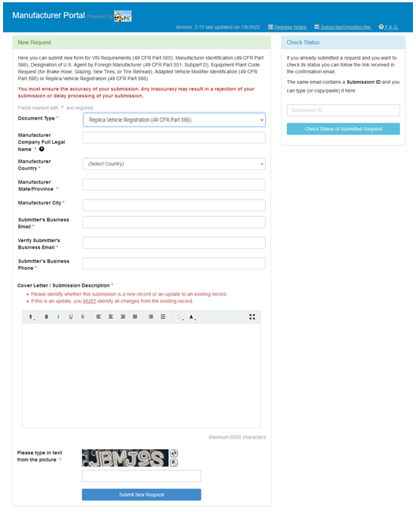

Step 2
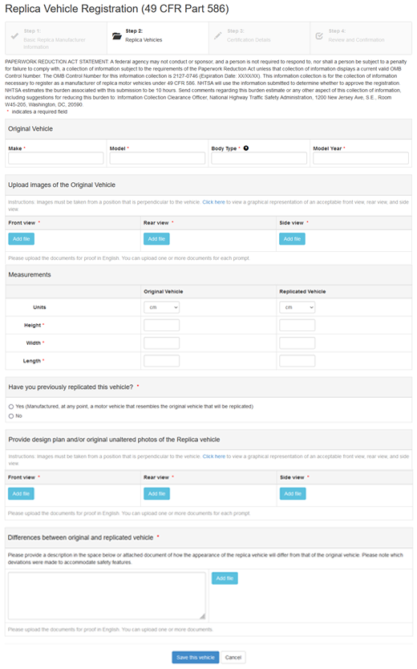
Step 3 – Additional Replica Vehicles
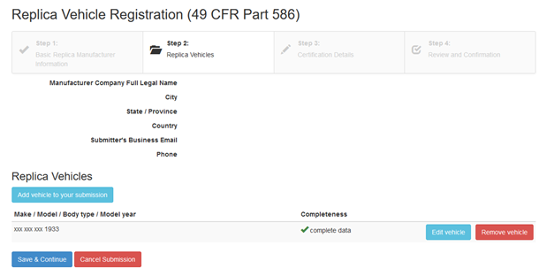

Step 4

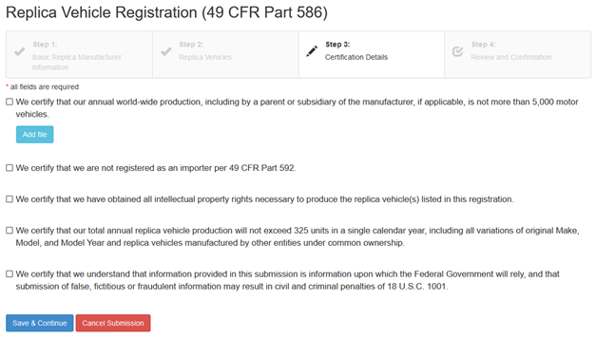

Registration Processing: Upon receipt of a registration submitted on vPIC, NHTSA will automatically send a confirmation email with a “Submission ID.” The registrant will be notified by email within 90 days of the receipt whether the registration is approved, denied, or incomplete. This notification will be sent to the email address provided in the manufacturer’s original submission. If an application is approved, the registrant’s name will automatically be added to the list of approved registrants on NHTSA’s website. The registration will be denied if: (a) NHTSA determines that the registrant does not meet program requirements; (b) the registration is incomplete, and the registrant has failed to provide the missing information within 60 days after being notified by NHTSA; or (c) the registration relies on the same facts and circumstances as a previously denied registration.
Incomplete Registration: NHTSA will notify the registrant by email within 90 days if it determines there is missing information. The registrant has 60 days to submit the missing information. NHTSA will then approve or deny the registration within a period of time equivalent to the number of days that were remaining in the original 90-day period at the time NHTSA sent the notification, plus an additional 30 days.
Deemed Approved Registration: If NHTSA does not act on a registration within 90 days of NHTSA’s receipt of the submission, the agency will notify a registrant by email on or after the 90th day that the registration has been deemed approved. Registrants that have been deemed approved will be included on NHTSA’s list of approved replica vehicle manufacturers. If a manufacturer has not received an email notification from NHTSA about the agency’s decision within the 90-day period, the registrant should contact NHTSA’s Manufacturers Helpdesk to determine the registration status: manufacturerinfo@dot.gov or 1-888-399-3277. (Manufacturers may contact the helpdesk for information about the status of the registration at any time. Go to the Manufacturer Portal (https://vpic.nhtsa.dot.gov/mfrportal/) and type into the “check status” box the Submission ID provided by NHTSA.) If NHTSA subsequently determines that a registration that had been deemed approved is incomplete, the agency may request additional information to be supplied within 60 days. A registration may be revoked if NHTSA determines that the manufacturer has not met the program requirements.
Manufacturer Has Previously Registered with NHTSA: If a company has previously registered with NHTSA as a manufacturer and is now seeking to produce replica vehicles, go to the Manufacturer Portal (https://vpic.nhtsa.dot.gov/mfrportal/) and under Document Type, select “Domestic Manufacturer’s Reporting Requirements” to help you pre-populate the form with existing data, then click “Replica Vehicle Manufacturer” and proceed to complete the steps detailed above.
- Updated Registration (New Replica Models): Registering as a replica vehicle manufacturer is a one-time event but manufacturers must update their registrations when intending to produce a new replica model. The process is essentially the same as the initial registration and the manufacturer may not begin producing the new model of replica vehicle until the request is either approved by NHTSA or deemed approved under the same 90-day process used to consider new applications.
  - Instructions: Go to the Manufacturer Portal (https://vpic.nhtsa.dot.gov/mfrportal/): Under “Document Type” select “Replica Vehicle Manufacturer” and provide the manufacturer’s legal name, country, state, city, submitter’s business email and phone number.
  - In the Cover Letter/Submission Description, note the following:
Provide the company’s Manufacturer’s Identification Number.
[Name of Manufacturer] is on NHTSA’s list of approved replica vehicle manufacturers
[Name of Manufacturer] is now seeking to produce a new replica model(s).
Proceed to steps 2, 3, and 4 which are the same as for submitting a new application (outlined above).
- Annual Report: Replica vehicle manufacturers are required to file annual reports and NHTSA is required to maintain an up-to-date list of registrants and a list of the makes and models of exempted motor vehicles at least annually (and publish such list in the Federal Register or on NHTSA’s website). No later than March 1 following the end of the calendar year, a manufacturer that had produced at least one replica vehicle must go to https://vpic.nhtsa.dot.gov/ and furnish the following information:
  - Full individual, partnership or corporate name of the manufacturer.
  - Residence address of the manufacturer, phone number and e-mail address.
  - Year to which the report applies (reporting year).
  - The complete Vehicle Identification Number (VIN) of each replica vehicle manufactured.
  - Vehicle make(s) and model(s).
  - Replica model year.
  - Original model year of the replicated vehicle(s).
  - Total number of replica vehicles manufactured during the reporting year.
  - Images of the front, rear, roof, and side views of the original vehicle(s) replicated, of the vehicle’s exterior, and images of the same views of a representative replica manufactured to resemble each original vehicle. Also submit information sufficient to establish that the replica vehicle, as manufactured, resembles the body of the original vehicle (i.e., refer to the original application submitted to NHTSA).
  - State whether the replica vehicles contain any of the following vehicle safety features: front or side air bags; lap or lap and shoulder belts; advanced safety systems/passive safety systems (listed with locations); electronic stability control; rear visibility camera system; ejection mitigation.
  - Provide NHTSA with an estimate of how many replica vehicles the manufacturer intends to produce in the next calendar year (per model if producing multiple models). Certify that the total number to be produced is no more than 325 replica vehicles. Certify that the manufacturers total annual world-wide production, including by a parent or subsidiary, if applicable, is not more than 5,000 motor vehicles for the next calendar year and for the 12 months prior to registering.
- Revocation of Registrations: NHTSA may request information related to compliance with the replica vehicle program at any time. The agency may revoke an existing registration or deny a registration based on a failure to comply or a finding of a safety-related defect or safety risk. Prior to revocation, the registrant will be provided a reasonable opportunity to correct any identified deficiencies.
- Foreign Company Registration: A foreign company must designate a U.S. Agent for Service of Process that will be the primary contact for the company in the event of a safety issue. Go to the Manufacturer Portal (https://vpic.nhtsa.dot.gov/mfrportal/) and click “Designation of U.S. Agent by Foreign Manufacturer (49 CFR Part 551, Subpart D). Click here for a suggested designation form: https://images.federalregister.gov/ER08AU05.043/large.png
- World Manufacturer Identifier (WMI) & Vehicle Identification Number (VIN): Replica vehicle manufacturers must obtain a manufacturer identifier, which is incorporated into the vehicle’s VIN. NHTSA has a contract with SAE International to assign manufacturer identifiers to manufacturers in the U.S. Foreign manufacturers must obtain a manufacturer identifier from the WMI-issuing entity in the country in which they are located. (If the country does not have a governing body to issue a WMI, SAE can issue a WMI for $525 USD.)
  - To obtain a WMI: call 724-772-8511 or click here: https://www.sae.org/standardsdev/groundvehicle/vin.htm
  - The WMIT application is found at: https://www.sae.org/standardsdev/groundvehicle/wmi/application/
- VIN Assignments: 49 CFR part 565 requires that a motor vehicle manufacturer assign each motor vehicle manufactured for sale in the United States a 17-character VIN that uniquely identifies the vehicle via a series of numbers and letters. For replica vehicles VINs, in addition to the information required for the replica vehicle’s type classification, the manufacturer must code the make, model, and year of the original motor vehicle being replicated into the “vehicle attributes” section of the VIN (positions four through eight). For additional information, visit: https://www.ecfr.gov/current/title-49/subtitle-B/chapter-V/part-565, and refer to § 565.15 Content requirements.

Additional NHTSA Requirements

- Temporary Label: Each replica vehicle shall have a temporary label attached to a location on the dashboard or the steering wheel hub that is clearly visible from all front seating positions. The label shall meet the following requirements:
  - The label shall include a heading area in yellow with an alert symbol consisting of a solid black equilateral triangle with a yellow exclamation point and the word “WARNING” in black block capitals in a type size that is larger than that used in the remainder of the label and the alert symbol in black.
  - The label shall include a message area in white with black text in at least 20-point font stating: “This vehicle is a replica motor vehicle and is exempt from complying with all current Federal motor vehicle safety standards that apply to motor vehicles, and with theft prevention and bumper standards in effect on the date of manufacture. [The expression “U.S.” or “U.S.A.” may be inserted before the word “Federal”.]
See the certification label for a list of the standards from which this replica motor vehicle is exempt.”
  - The message area shall be not less than 30 centimeters (4.7 inches).

- Certification Label
  - The manufacturer must affix a certification label to each replica motor vehicle of the type and manner as described below.
  - The label shall be riveted or permanently affixed in such a manner that it cannot be removed without destroying or defacing it.
  - The label shall be affixed to either the hinge pillar, door-latch post, or the door edge that meets the door-latch post, next to the driver's seating position, or if none of these locations is practicable, to the left side of the instrument panel. The location of the label shall be such that it is easily readable without moving any part of the vehicle except an outer door.
  - The lettering on the label shall be of a color that contrasts with the background of the label.
  - The label shall contain the following information and statements, in the English language, lettered in block capitals and numerals not less than 3/32 of an inch high, in the order shown:
(1) Name of manufacturer: the full corporate or individual name of the actual assembler of the vehicle shall be spelled out, except that such abbreviations as “Co.” or “Inc.” and their foreign equivalents, and the first and middle initials of individuals, may be used. The name of the manufacturer shall be preceded by the words “Manufactured By” or “Mfd By.”
(2) Month and year of manufacture: This shall be the time during which work was completed at the place of main assembly of the vehicle. It may be spelled out, as “June 2000,” or expressed in numerals, as “6/00.”
(3) “Gross Vehicle Weight Rating” or “GVWR” followed by the appropriate value in pounds, which shall not be less than the sum of the unloaded vehicle weight, rated cargo load, and 150 pounds times the number of the vehicle's designated seating positions.
(4) “Gross Axle Weight Rating” or “GAWR,” followed by the appropriate value in pounds, for each axle, identified in order from front to rear (e.g., front, first intermediate, second intermediate, rear). The ratings for any consecutive axles having identical gross axle weight ratings when equipped with tires having the same tire size designation may, at the option of the manufacturer, be stated as a single value, with the label indicating to which axles the ratings apply.
Examples of combined ratings: GAWR:
(i) All axles—2,400 kg (5,290 lb.) with LT245/75R16(E) tires.
(ii) Front—5,215 kg (11,500 lb.) with 295/75R22.5(G) tires.
First intermediate to rear—9,070 kg (20,000 lb.) with 295/75R22.5(G) tires.
(5) The following statement: “This vehicle is a replica motor vehicle that replicates a [insert make and model of the replicated motor vehicle] originally manufactured in model year [insert year].”
(6) Either:
(i) The statement: “This replica motor vehicle is exempt from the following Federal motor vehicle safety, theft prevention, and bumper standards in effect on [insert the date of manufacture of the replica motor vehicle] for [insert replica’s type of motor vehicle (e.g., passenger cars)]: [insert a list of all standards from which the vehicle is exempt pursuant to 49 U.S.C. 30114(b)].” (The expression “U.S.” or “U.S.A.” may be inserted before the word “Federal”); or
(ii) The statement: “This replica motor vehicle is exempt from the Federal motor vehicle safety, theft prevention, and bumper standards in effect on [insert the date of manufacture of the replica motor vehicle] for [insert replica’s type of motor vehicle (e.g., passenger cars)] that are listed on the label found in [insert location of label listing standards from which the vehicle is exempt under 49 U.S.C. 30114(b)]”; and
(7) Vehicle identification number.
  - If the label required under paragraph (a) includes the statement found in paragraph (e)(6)(ii) above, the manufacturer must affix to the replica vehicle a second label that meets the following criteria:
(1) The label shall be riveted or permanently affixed to the vehicle in such a manner that it cannot be removed without destroying or defacing it;
(2) The label shall be affixed to the location identified in paragraph (e)(6)(ii).
(3) The lettering on the label shall be of a color that contrasts with the background of the label.
(4) The label shall contain the following statements, in the English language, lettered in block capitals and numerals not less than 3/32 of an inch high: “This replica motor vehicle is exempt from the following Federal motor vehicle safety, theft prevention, and bumper standards in effect on [insert the date of manufacture of the replica motor vehicle] for [insert replica’s type of motor vehicle (e.g., passenger cars)]: [insert a list of all standards for which the vehicle is exempt pursuant to 49 U.S.C. 30114(b)].”
- Limitations on Exemptions: A replica vehicle manufacturer shall be considered a motor vehicle manufacturer for purposes of parts A and C of subtitle VI of 49 USC (covering “Motor Vehicle Safety” and “Information, Standards, and Requirements”). Nothing shall be construed to exempt a replica vehicle manufacturer from complying with the requirements under 49 USC Sections 30116-30120A (covering defects and remedies). See: https://www.law.cornell.edu/uscode/text/49/subtitle-VI/part-A/chapter-301/subchapter-II
- Recordkeeping: A Low-Volume Manufacturer shall maintain for five (5) years all records supporting its Registration and Annual Reports and all other recordkeeping requirements of 49 CFR Part 576.
- Imports: Replica motor vehicles may be imported into the U.S. by a registered replica vehicle manufacturer if they are properly labeled and otherwise in compliance with the NHTSA regulations. The total number of replica motor vehicles imported into the U.S. by a foreign replica vehicle manufacturer, including all of its U.S.-based importers combined, shall be included when determining compliance with the 325 vehicles per calendar year limitation. Importers should mark box “2A” on NHTSA’s HS-7 declaration form, Importation of Motor Vehicles and Motor Vehicle Equipment Subject to Federal Motor Vehicle Safety, Bumper Standards, when importing a replica motor vehicle.
- State Registration and Titling: Nothing in this Guidance shall be construed to preempt, affect, or supersede any State titling or registration law or regulation for a Replica Motor Vehicle, or exempt a person from complying with such law or regulation.

